**SUPPLEMENTARY FIGURE S7: Cost-effectiveness analysis framework**

**economic evaluation relative to nice thresholds**

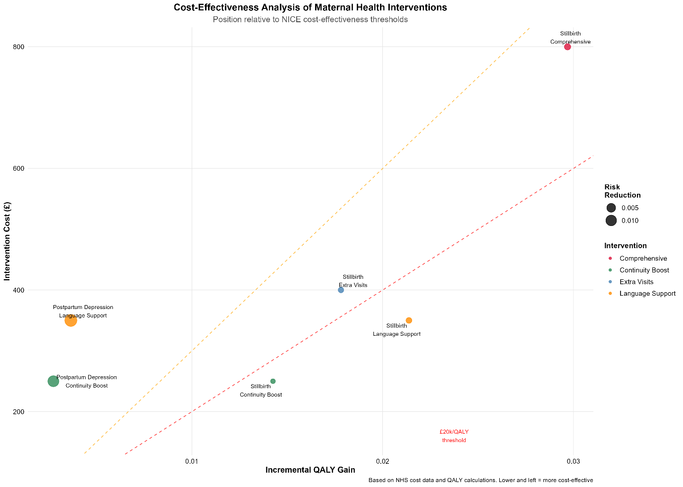

Cost-effectiveness analysis maternal health interventions positioned relative to NICE cost-effectiveness thresholds (£20k/QALY and £30k/QALY lines). Lower left quadrant indicates most cost-effective interventions. Stillbirth comprehensive interventions show high impact but exceed cost-effectiveness thresholds. Continuity boost for postpartum depression demonstrates optimal cost-effectiveness profile.